18F Style Guide

FAA Template / ATOMS

Style Guide

Contents

3 Typography

8 Grid

14 Tables

16 Boxes

18 Buttons

20 Icons

24 Colors

26 FDA Example

TYPOGRAPHY
Typography

Default Font Attributes

Font: Helvetica Neue

Fall Back: Arial, Sans-Serif

Font Size: 12px = 1.2rem (base)

Font Weight: 500

Font Color: #333333

A Href (Links)

Default a href Attributes a:link { color: #0076C0;} a:visited {N/A}

a:hover {color: #0076C0; text-decoration: underline;} a:active {color: #333333;}

a href Attribute when on Blue Background

a:link { color: #FFFFFF;} a:visited {N/A}

a:hover {color: #FFFFFF; text-decoration: underline;}

a:active {N/A}

4 | 18F Style Guide

Navigation Font Attributes

Default

Font Size: 14px

Font Color: #333333

Font Weight: 500

Primary Navigation

a href Attributes a:link { color: #0076C0;} a:visited {N/A}

a:hover {color: #0076C0; text-decoration: underline;} a:active {N/A}

a href Attribute when on Blue Background

a:link { color: #FFFFFF;} a:visited {N/A}

a:hover {color: #0076C0; text-decoration: underline;}

a:active {color: #333333;} White Tab with 15px left and right padding required
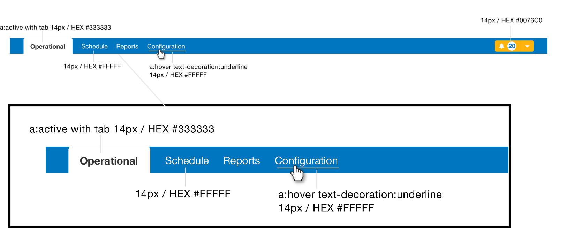

5 | 18F Style Guide

Navigation Font Attributes

Secondary Navigation

Default

Font Size: 14px

Font Color: #333333

Font Weight: 500

a href Attributes a:link { color: #0076C0;} a:visited {N/A}

a:hover {color: #0076C0; text-decoration: underline;} a:active {color: #333333; font-weight: 700;}
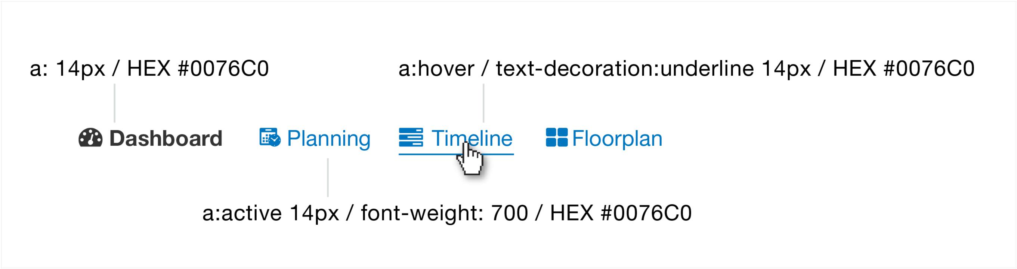

6 | 18F Style Guide

Footer Font Attributes
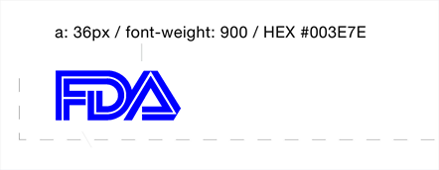

36px

7 | 18F Style Guide

GRID

8 | 18F Style Guide

Grid

The responsive grid has a default width of 1200px with a 30px gutter.

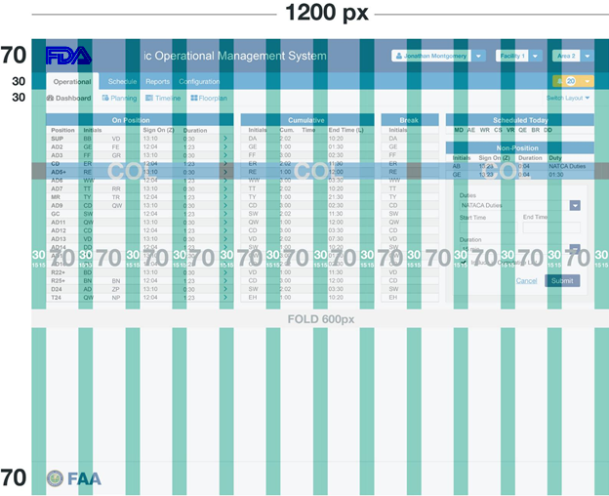

9 | 18F Style Guide

Logo Header Grid

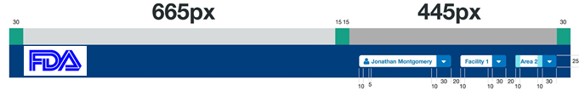

In this example, the application has chosen to allow access to sign in information, and access to other critical facilities and areas used throughout their application.

10 | 18F Style Guide

Navigation Grid

Primary Navigation
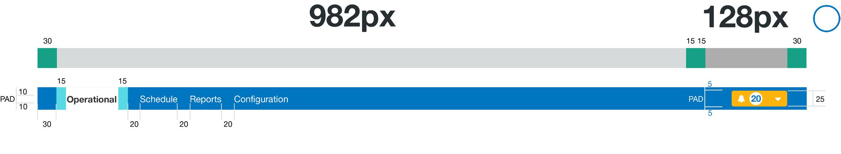

1

Primary Nav bar padding: 10px 15px 10px 30px (Height is determined by a font size of 14px)

Second col of the primary nav bar padding: 5px 30px 5px 15px

Space Between Nav Elements: 20px Left and right padding on tabs: 15px

- A small space on the navigation bar is reserved for an item of your choice that you may want to use in your application. This space is 128 pixels on the navigation bar.

In this example, the application has chosen to allow access to all their alerts in their application, regardless of the page they are on.


11 | 18F Style Guide

Navigation Grid

Secondary Navigation
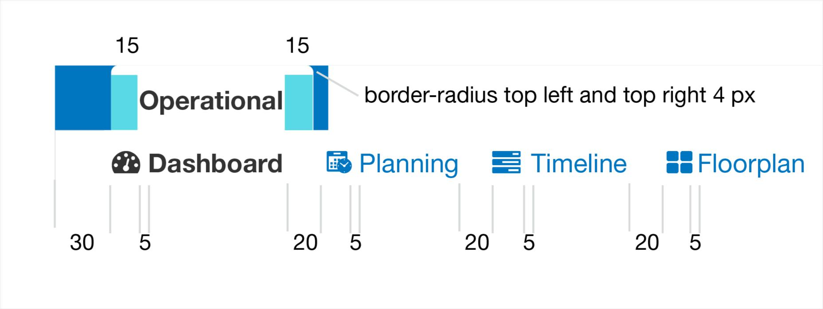
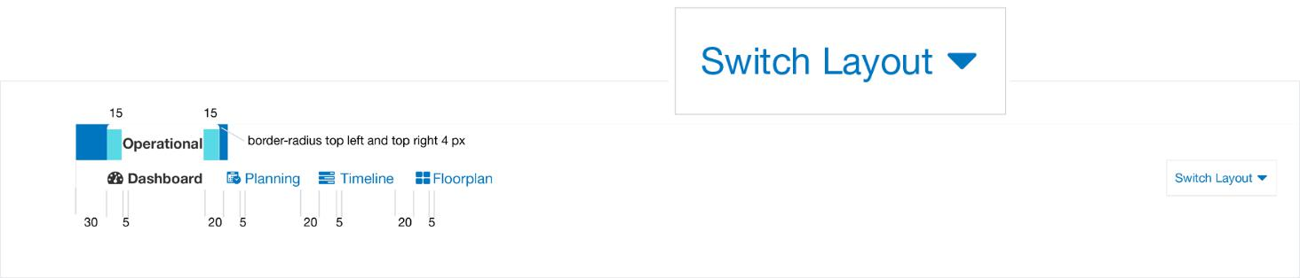

See page 27 for example 

Full Page Width

Space Between Nav Elements: 20px

Space Between Icons and Nav Elements: 5px

Left and right padding on tabs: 15px with a left and right border radius of 4px

12 | 18F Style Guide

Footer Grid

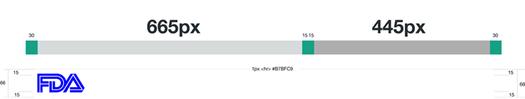

36px

The Global Footer is below every page of the application and is approximately 66px in height.

The height is determined by a logo and font size of 36px and 15px top and bottom padding.

13 | 18F Style Guide

TABLES

14 | 18F Style Guide

Tables
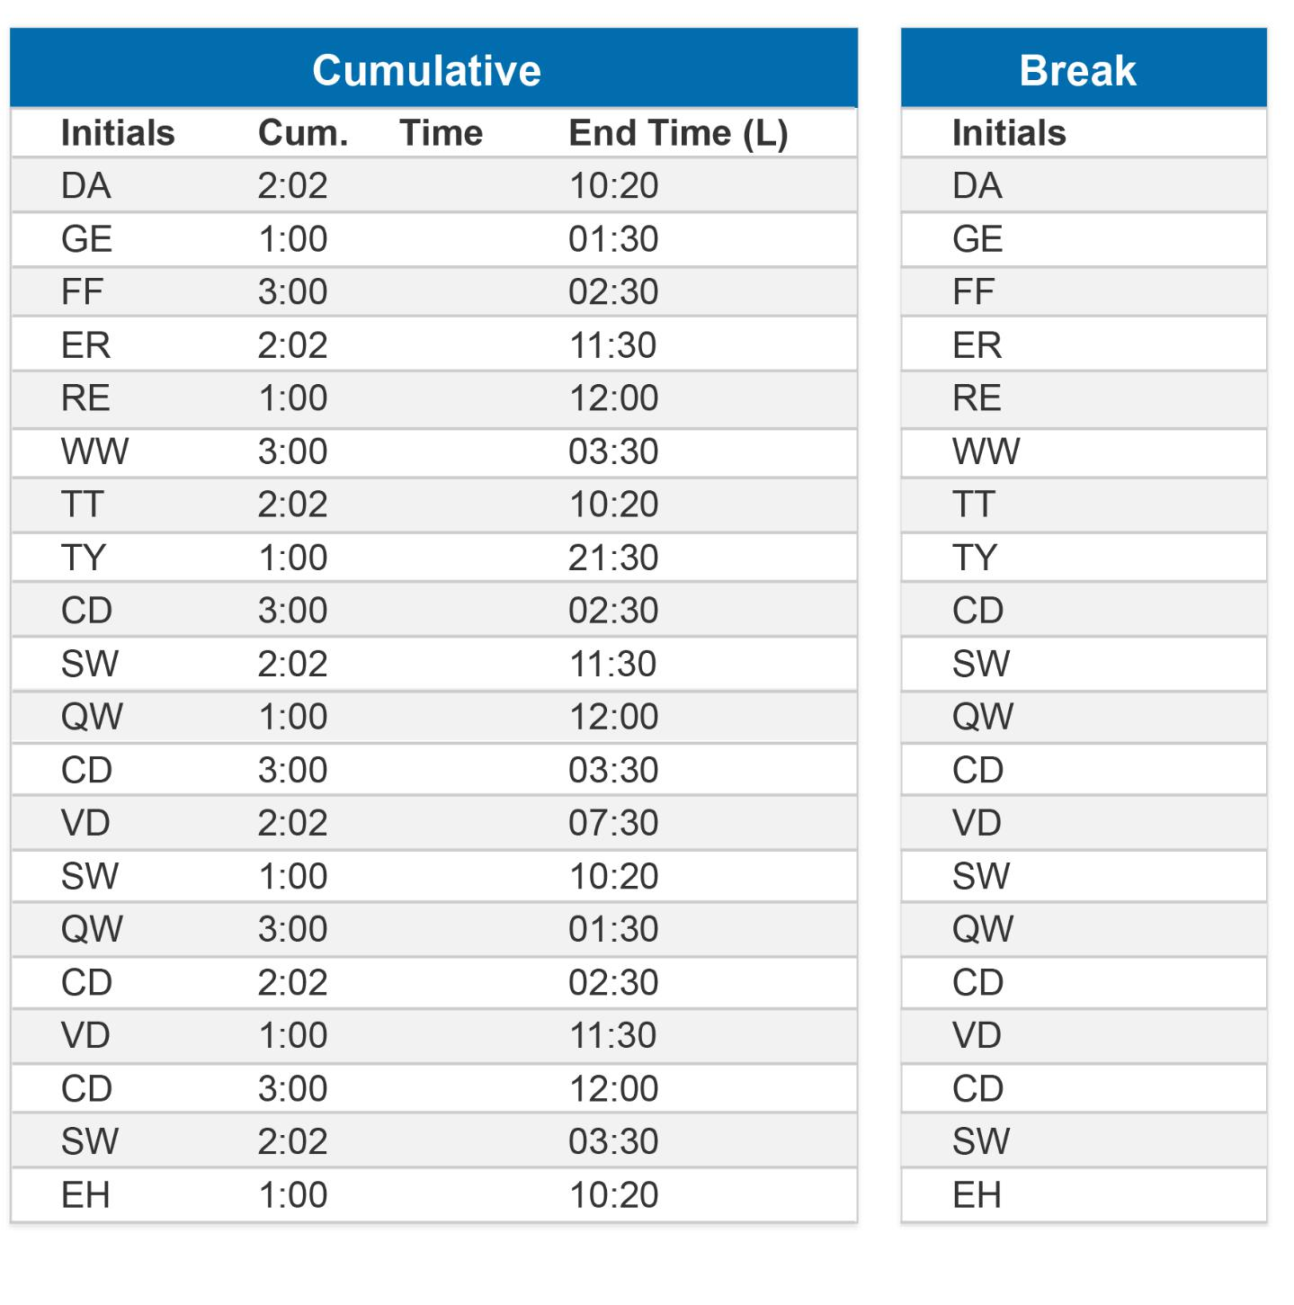

All data in tables are 12px

Boxes have a 15px margin between them Table header text is 14px Bold

Table cells have a 5 px padding

Table rows have a alternate color of #F2F2F2

15 | 18F Style Guide

BOXES

16 | 18F Style Guide

Boxes

By default boxes receive a 1px border, a border color of #CCCCCC and a white background color #FFFFFF.

Boxes have an interior padding of 15px and a 15px margin between boxes. (This may need to be 20px or 30px need to talk to DEV)


15 15

Padding 15px |  | Margin 15px
Padding 15px |  | between boxes

15 15

White #FFFFFF background-color

17 | 18F Style Guide

BUTTONS

18 | 18F Style Guide

Buttons

Button Font and Padding Attributes

Mini: 12px font - padding: 3px 5px Small: 12px - padding: 5px 7px Default: 14px font- padding: 8px 15px Large: 18px font - padding: 10px 15px
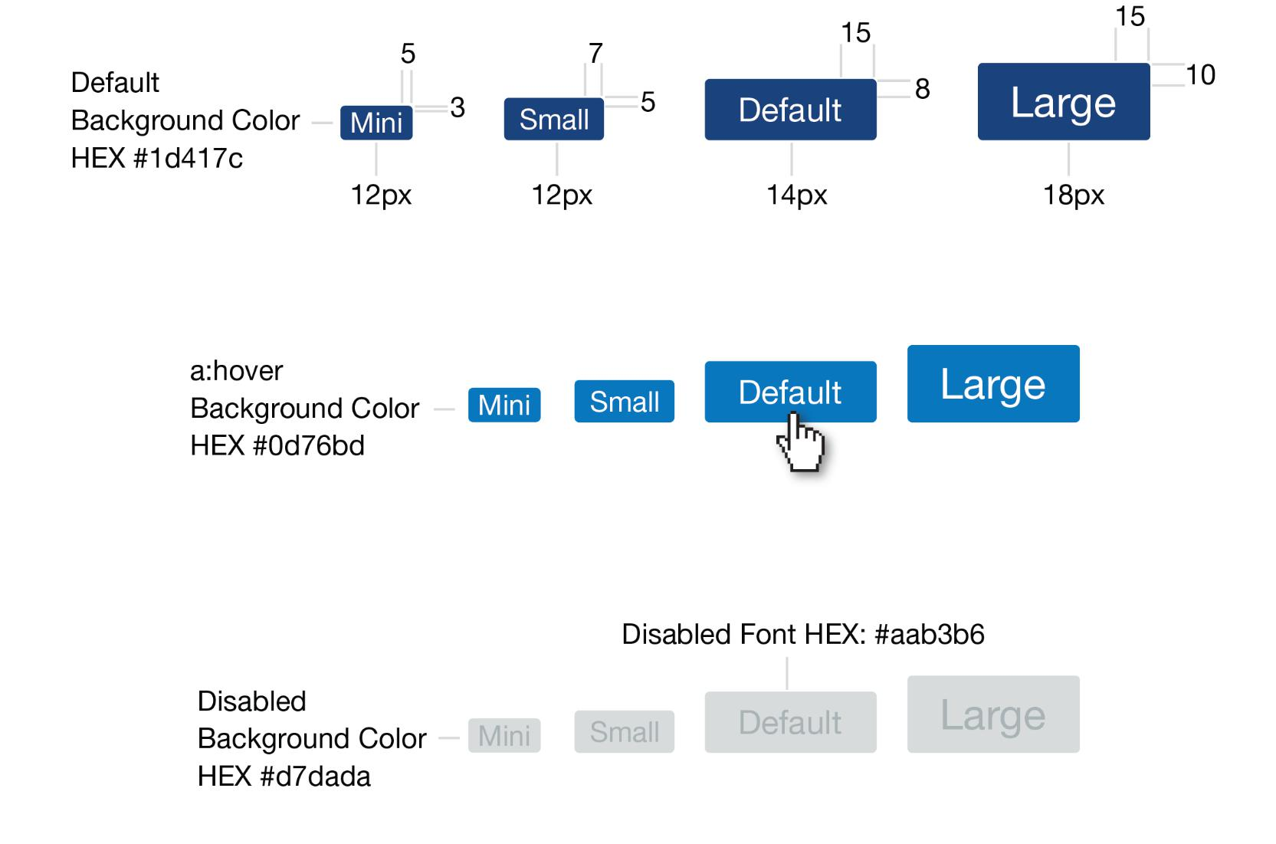

19 | 18F Style Guide

ICONS

20 | 18F Style Guide

Icons - Font Awesome

Web Scaling Code Example

<i class=”fa fa-spinner”></i>





12px 20px 30px reverse

Icons

Font Awesome | Icon Name (based on usage) | Icon
Icon Class | Icon Name (based on usage) | Icon
fa-spinner | Loading
fa-home | Home
fa-cog | Settings
fa-pencil | Edit
fa-trash-o | Delete
fa-user | User
fa-user-plus | Add User
fa-calendar | Calendar function
fa-binoculars | Find








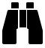

21 | 18F Style Guide

Font Awesome | Icon Name (based on usage) | Icon
Icon Class | Icon Name (based on usage)
fa-cloud-download | Download (from the cloud)
fa-bar-chart | Business Data (graphed)
Fa-comment | Comments
fa-times | Close or Delete
fa-tachometer | Dashboard
fa-envelope | Email
fa-filter | Filter
fa-file | File
fa-file-text | Document
fa-folder | Folder
fa-folder-open | Open Folder
fa-heart | Favorite
fa-info-circle | Info
fa-bars | Navicon (Hamburger menu)
fa-plane | Aircraft or Airspace
Fa-plus | Add

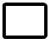









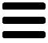





22 | 18F Style Guide

Font Awesome | Icon Name (based on usage) | Icon
Icon Class | Icon Name (based on usage) | Icon
Fa-print | Print
fa-question-circle | Help
fa-search | Search
fa-sort | Sort
fa-star | Star (Important; Favorite)
fa-exclamation-triangle | Warning
fa-wrench | Tools
fa-floppy-o | Save
fa-link | Link
fa-chain-broken | Unlink
fa-list-ul | List View
fa-table | Table View
fa-undo | Undo
fa-check | Check mark or Validate



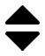




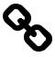


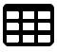



23 | 18F Style Guide

COLORS

24 | 18F Style Guide

Colors

Primary Colors

Dark Blue Light Blue Light Grey

HEX: #003E7E |  | HEX: #0076C0 |  | HEX: #E9EAED
RGB: 0 62 126 |  | RGB: 0 118 192 |  | RGB: 233 234 237

Alert Colors

Red Yellow Green

HEX: #FC4349 |  | HEX: #FFB30C |  | HEX: #71B300
RGB: 252 67 73 |  | RGB: 255 179 12 |  | RGB: 113 179 0

25 | 18F Style Guide

ATOMS EXAMPLE

26 | 18F Style Guide

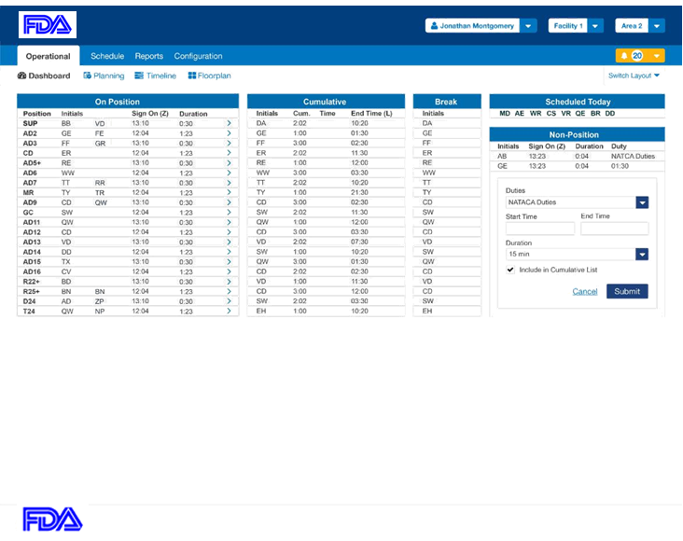

27 | 18F Style Guide

